Lesson 02 – Inputs, Variables, and Math Assignments

All coding assignments will be name Lab (Lesson Number) _ (Problem Number).java unless otherwise stated. EX: Lab01_01.java

Add a comment in the first couple line of your code with your name and the date.

All written assignments will be name Lab (Lesson Number) _ Questions.txt or Lab (Lesson Number) _ Questions.docx. The question will go inside.

In the header of the doc or first few line (txt), put your name and the date.

**Comment all code in meaningful ways that would help other, not knowing about coding, understand what is going on.**

Coding Problems

1. Create a simple calculator what will add the two number that the user inputs and display the result.
2. Create a simple calculator what will subtract the two number that the user inputs and display the result.
3. Create a simple calculator what will multiply the two number that the user inputs and display the result.
4. Create a simple calculator what will divide the two number that the user inputs and display the result. A division error should have occurred. In the doc, explained how you fixed this problem.
5. Create a BMI Calculator that will ask the user for their name, weight and height and output their name and BMI.
6. Create a calculator that will calculate the volume of a cylinder.
7. Create a calculator that will calculate the surface area of a cylinder.

Debugging problems

1. 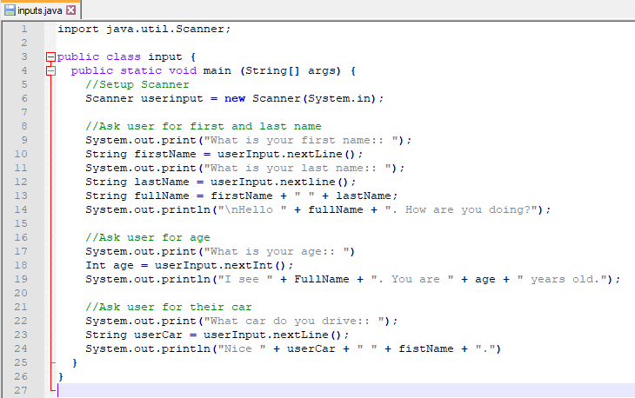
   1. There are 9 errors find all of them
2. On my github there is a inputs.java class that when run, skips over asking the user for the car. Fix this error in the code and turn it in. Also write what the error is, why it occurs, and how you fixed it.